

Target: /50 or ____%

Name: _____________________ Teacher: __________________

**Year 7 Economics and Business (HASS) – Weighting 15%**

Task 9 – In-class Test

Key Topic – Consuming and Producing

**Total**

____________

50

**Section One – Multiple Choice**

**1 mark per question**

Short Answer: Your Mark out of 10 _________

1. Economics is the study of how people:
2. survive by satisfying their needs
3. earn an income so they can buy goods and services
4. satisfy unlimited wants by preparing a budget
5. use limited resources to satisfy unlimited wants

2. The best definition of goods in economics is they are:

1. provided for us by other people
2. provided by your parents
3. items you can see or touch
4. things that you cannot see or touch

3. Which of the following items is not considered a need?

1. food
2. water
3. electricity
4. shelter

4. Wants can be defined as:

1. luxuries which are not essential for survival
2. the desire to be the best we can be
3. unlimited resources
4. things that we need for survival

5. The best definition of income is:

1. wages earned by workers
2. items of value owned
3. money spent on goods and services
4. payment received for providing resources such as labour

6. Which of the following is not one of the four economic resources?

1. natural resources
2. labour resources
3. capital resources
4. non-renewable resources

7. Land resources can be defined as:

1. new ideas and methods in producing goods and services
2. raw materials supplied by nature
3. machinery and technology
4. human skill and effort

8. Which of the following is not a role of the consumer in the economy?

1. provide producers with resources
2. pay income in return for resources
3. spend money on goods and services
4. save income in financial institutions such as banks

9. Bill works as a car salesman at Grand Toyota Wangara. The type of income he most likely earns is:

1. a salary
2. a wage
3. commission
4. piece rates

10. The main goal of all businesses in the Australian economy is to:

1. produce goods and services
2. make the most amount of profit possible
3. satisfy needs and wants
4. protect natural resources for future generations

**Section Two – Short Answer**

11. Using examples, explain the difference between needs and wants. (4 marks)

______________________________________________________________________________________________________________________________________________________________________________________________________________________________________________________________________________________________________________________________________________________________________________________________________

______________________________________________________________________________

______________________________________________________________________________

12. Classify the following list of resources into Land, Labour, Capital and Enterprise. Write the name of each resource under the appropriate column in the table provided below. (10 marks)

**water taxi carpenter iron ore computer**

**bookcase electrician forest boat warehouse**

**bank manager truck factory ice cream video store owner**

**teacher wood principal oil paper**

|  |  |  |  |
| --- | --- | --- | --- |
| **LAND** | **LABOUR** | **CAPITAL** | **ENTERPRISE** |
|  |  |  |  |
|  |  |  |  |
|  |  |  |  |
|  |  |  |  |
|  |  |  |  |
|  |  |  |  |
|  |  |  |  |
|  |  |  |  |
|  |  |  |  |

13. Match the terms and definitions listed below by writing the letter next to the corresponding statement in the space provided. (8 marks)

**A** resources **E** profit

**B** welfare **F** wage

**C** salary  **G** services

**D** consumers **H** banks

(i) ____ The action provided by someone in order to satisfy needs and wants.

(ii) ____ Earned when the money received by businesses is greater than the costs of

operating it over a period of time.

(iii) ____ People who demand and use goods and services in order to satisfy their needs

and wants.

(iv) ____ A fixed regular payment, typically paid on a monthly basis but often expressed as an annual sum.

(v) ____ Anything or anyone that is used to produce goods and services.

(vi) ____ An organisation which accepts deposits, pays interest, clears cheques and

provides loans to customers

(vii) ____ Money paid by the government to support people who are unable to work.

(viii) ____ A fixed regular payment earned for work or services, typically paid weekly basis based on the number of hours worked.

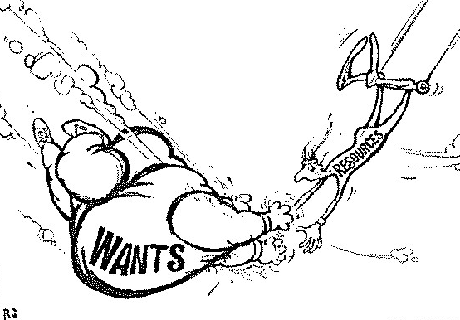14. Study the cartoon below and answer the questions that follow.

a) Why do you think the “WANTS” man is larger than the “RESOURCES” man? (1 Mark)

__________________________________________________________________________________________________________________________________________________________________________________________________________________________________________

b) What is the “RESOURCES” man attempting to do in the cartoon? (1 mark)

__________________________________________________________________________________________________________________________________________________________________________________________________________________________________________

c) How does the cartoon illustrate the concept of the economic problem? Explain your

answer in detail by referring to the cartoon. (4 marks)

______________________________________________________________________________________________________________________________________________________________________________________________________________________________________________________________________________________________________________________________________________________________________________________________________________________________________________________________________________________________________________________________________________________________________________________________________________________________________________________________________________________________________________________________

______________________________________________________________________________

15. State the name of an entrepreneur. (1 Mark)

______________________________________________________________________________

16. Use this example to explain what an entrepreneur is. (3 marks)

__________________________________________________________________________________________________________________________________________________________________________________________________________________________________________

__________________________________________________________________________________________________________________________________________________________________________________________________________________________________________

17. With reference to the entrepreneur you studied. Explain how they used one or more of the main characteristics of entrepreneurs. (Innovation, Initiative, Perseverance, Risk-Taking).(4 marks)

____________________________________________________________________________________________________________________________________________________________________________________________________________________________________________________________________________________________________________________________________________________________________________________________________________________________________________________________________________________________________________________________________________________________________________________________________________________________________________________________________________________________________________________________________________________________________________________________________________

__________________________________________________________________________________________________________________________________________________________________________________________________________________________________________

18. List 2 similarities and 2 differences between Full-time and Casual work. (4 marks)

**Similarities:**

1. __________________________________________________________________________________________________________________________________________________
2. __________________________________________________________________________________________________________________________________________________

**Differences:**

1. __________________________________________________________________________________________________________________________________________________
2. __________________________________________________________________________________________________________________________________________________

**END OF ASSESSMENT**